CPRE AVON and BRISTOL
seeks a new TREASURER
to ensure our charity remains financially resilient, sustainable and well-positioned for long-term growth.

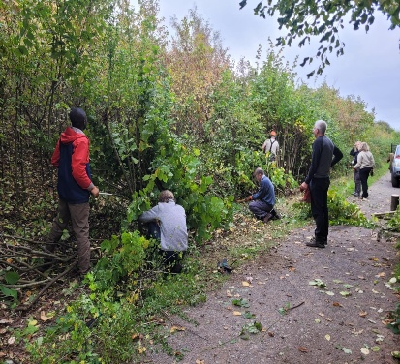

Location: Bristol/Surrounding Area
Salary: Voluntary / Unremunerated / Expenses Paid

Time Commitment: Approximately 1-2 days per month. Currently, 4 Board meetings per annum, plus occasional ad-hoc meetings, preparation and support for budgeting, annual accounts and financial planning

WHO WE ARE

CPRE Avon and Bristol is an independent charity that exists to protect and regenerate the countryside around Bristol, Bath and the surrounding rural areas of North Somerset and South Gloucestershire. It sits within the highly respected network of CPRE charities that operate in almost every English County headed by the influential National Charity HQ in London.

We work with our members, local communities and volunteers to protect our countryside from unsustainable development and practices. We run projects that connect people from diverse groups to their local countryside. We help deepen their and our understanding of local issues to strengthen our campaigning to create a thriving, sustainable and biodiverse environment for all to enjoy.

ABOUT THE ROLE

You will join and work alongside the Chair and a committed Board of Trustees to oversee the charity's financial management. As Treasurer, you will help ensure robust financial controls, accounting, reporting and effective governance and informed decision-making.

You will play a key role in:
- Providing strategic financial oversight and assurance to the Board
- Supporting long-term financial sustainability and organisational resilience
- Strengthening financial governance
- Advising the Trustees on their financial duties and the viability of the charity, ensuring that financial information is accessible for non-financial trustees
- Monitoring internal financial controls and risk management systems
- Overseeing the setting of annual budgets for the organisation, forecasting and reserve management
- Keeping accurate records of income and expenditure in line with accounting rules and legal requirements
- Being a signatory for payments and reimbursing invoices and expenses
- Preparing financial reports and submitting accounts for independent audit
- Updating National CPRE about our charity finances
- Assisting with funding applications and accounting for external funding
- Where relevant, liaising with the payroll company to ensure employment regulations are met (e.g. staff salaries, pension enrolment and payments, national insurance and payments to HMRC)

Previous charity trustee experience would be welcome but is not essential. Experience of charity finance, accounting regulations and Charities Statement of Recommended Practice (SORP) is also highly valuable. We would love to hear from you.

WHO WE’RE LOOKING FOR
We are open to different backgrounds and pathways into this role. You may already be a Finance Trustee, Treasurer or Finance Committee Chair, or you may be a senior finance professional looking to take on your first board-level governance role. What matters most is your ability to provide relevant strategic financial leadership and support effective decision-making.

We're particularly interested in people who can:
- Demonstrate strong financial management
- Interpret financial information and translate it clearly for non-financial audiences
- Support strategic thinking around growth, sustainability and income diversification
- Balance scrutiny and challenge in a collaborative and supportive way
- Operate confidently at both strategic and governance level
- Bring a passion for environmental and countryside issues
APPLICATION PROCESS

- The closing date for applications is: 31 October 2026
- Interviews will be initially online, and short listed candidates will be invited to an in person interview in or near Bristol
- To apply, please submit a CV and covering letter addressing the criteria detailed above and using examples from your previous experience. Please include your reasons and motivations for applying for this role of TREASURER as well as your contact details, including your mobile and email.
- All applications should be submitted to: admin@cpreavonandbristol.org.uk
- For more information about the work we do: www.cpreavonandbristol.org.uk

